Answer ALL the questions

1. Write an appropriate function prototype based on the following descriptions:
   1. A function named distance. The function should return a double and have two

double parameters: rate and time

* 1. A function named days. The function should return an int and have three int

parameters: years, months, and weeks.

* 1. A function named getKey. The function should return a char and use no parameters.

1. The following statement calls a function named half, which returns a value that is half that of the argument passed to it.

result = half(number);

Assume that result and number have both been defined to be double variables. Write the

half function. (Note: just write the function. Do not write a complete program.)

1. What is the output of the following program?

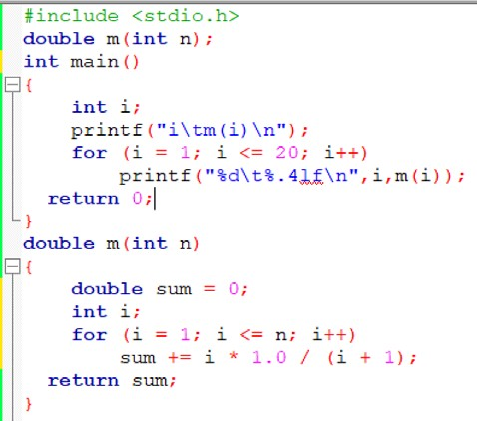

1. In physics, an object that is in motion is said to have kinetic energy. The following formula can be used to determine a moving object’s kinetic energy: KE =(1/2)mv2 where KE is the kinetic energy in Joules, m is the object’s mass in kilograms, and v is the object’s velocity, in meters per second. Write a function that accepts an object’s mass and velocity as arguments. The function should return the amount of kinetic energy that the object has.
2. Suppose a particle is moving along the x-axis so that its position at time 𝑡 is given by the formula ff(t) = 3t2+7t-2t5/2
   1. Find the velocity and acceleration as functions of 𝑡.
   2. Write a program that computes the particle position, velocity and acceleration for time 𝑡 =

0 until 𝑡 = 1.5 with increment size of 0.15. Positive velocity is referred to the particle is moving in the positive direction (toward the right). Negative acceleration means that the velocity is decreasing at that point.

1. Write a program that demonstrates the functions to compute the average and standard deviation of four scores. Imply the sentinel value to end the program as shown in the sample output file. The following formula can be used to calculate the average and standard deviation.

The sample output file is shown below:

Press Y to enter the program or press any button to exit: Y Enter 4 numbers, I will give you the mean and standard deviation of the data

12.3

13.4

10.5

9

Mean of 12.30, 13.40, 10.50 and 9.00 is 11.30

The standard deviation of these numbers is 1.122497

Press Y to enter the program or press any button to exit: X You wished to exit. Thank you

1. Write a C program to solve the following equations by using the subprograms/functions.

𝑓(𝑥, 𝑦) = 𝑥2 + 𝑦2 − 2𝑥 + 8𝑦 – 8

𝑔(𝑥, 𝑦) = $\frac{{\left(x-6\right)}^{2}}{36}+\frac{{\left(y+4\right)}^{2}}{16}-1$

Let the user enter the values of 𝑥 and 𝑦. Let the user choose either to compute *f(x,y)* or *g(x,y)*. Imply the sentinel value to end the program. Define two functions which handle these equations respectively. Both functions must return a single value. The output must be in the third function which only prints the answer. [Note: Your program consists of **four functions** including the main program]. The sample output file is shown below:

0 to exit the program

1 for f(x,y)=x^2+y^2-2x+8y-8

2 for g(x,y)=1/36*(x-6)^2+1/16*(y+4)^2-1

Please choose your function: 1 Enter the value of x and y:

x = -2

y = 1

The value of f(x,y) when x = -2.0 and y = 1.0 is: 9.0

Please choose your function: 0 You wished to exit. Thank you